

**COMPUTER SCIENCE AND ENGINEERING**

**DISTRIBUTED SYSTEMS – CSE 5306 – 003**

**PROJECT-1**

**Team Members**

|  |  |
| --- | --- |
| **Name** | **Student Id** |
| Shreya Malraju | 1002046338 |
| Jyothi Bhavani Patibandla | 1001960841 |

I have neither given nor received unauthorized assistance on this work. I will not post the project description and the solution online.

Sign: Shreya Malraju Date: September 11, 2023

Sign: Jyothi Bhavani Patibandla Date: September 11, 2023

**Part 1 : Multi-threaded file server**

Contribution – Upload and Download operations – Shreya

Rename and Delete operations – Jyothi

XML-RPC is a remote procedure call that uses XML, transported via HTTP. By using this procedure, a client can make request to a server and can obtain the response in return.

We perform 4 different operations i.e.,

⦁ UPLOAD

⦁ DOWNLOAD

⦁ RENAME

⦁ DELETE

To find out what operations the fileserver supports, enter the following command.

python client.py -h

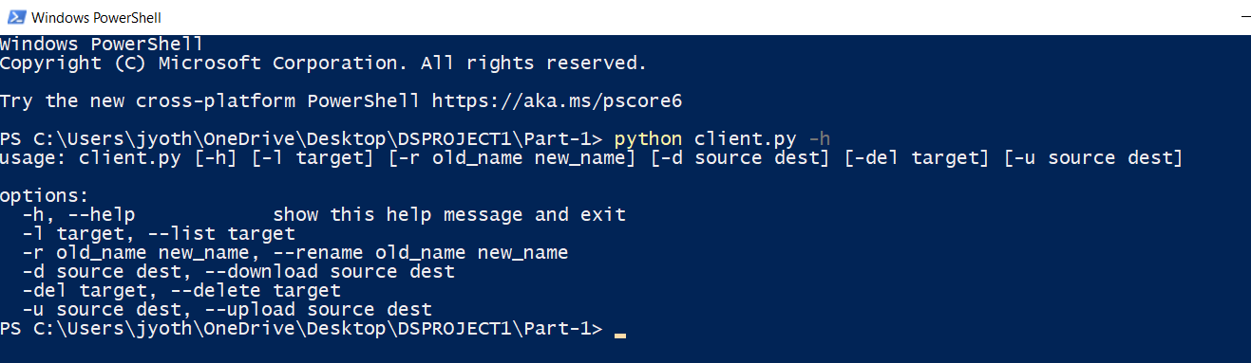

Start to run the server using the command: Python server.py

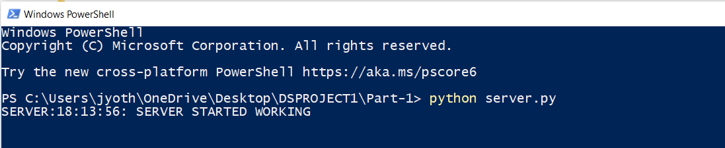

we see that the Client and server directories having no files in it.

By running the following commands

python client.py -l client



python client.py -l server



Adding File to the client directory and checking both client and server

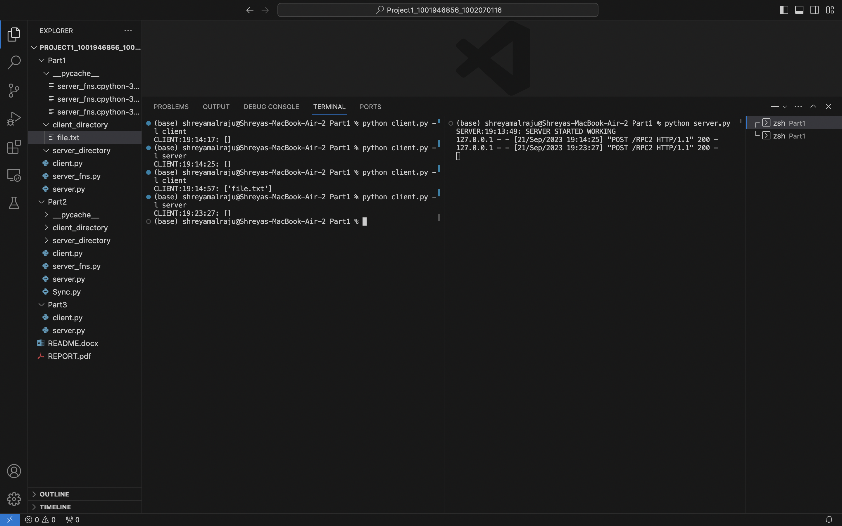

**Performing Upload Operation:**

Run the following command to upload the file to the server:

python client.py -u client_filename server_directory/filename

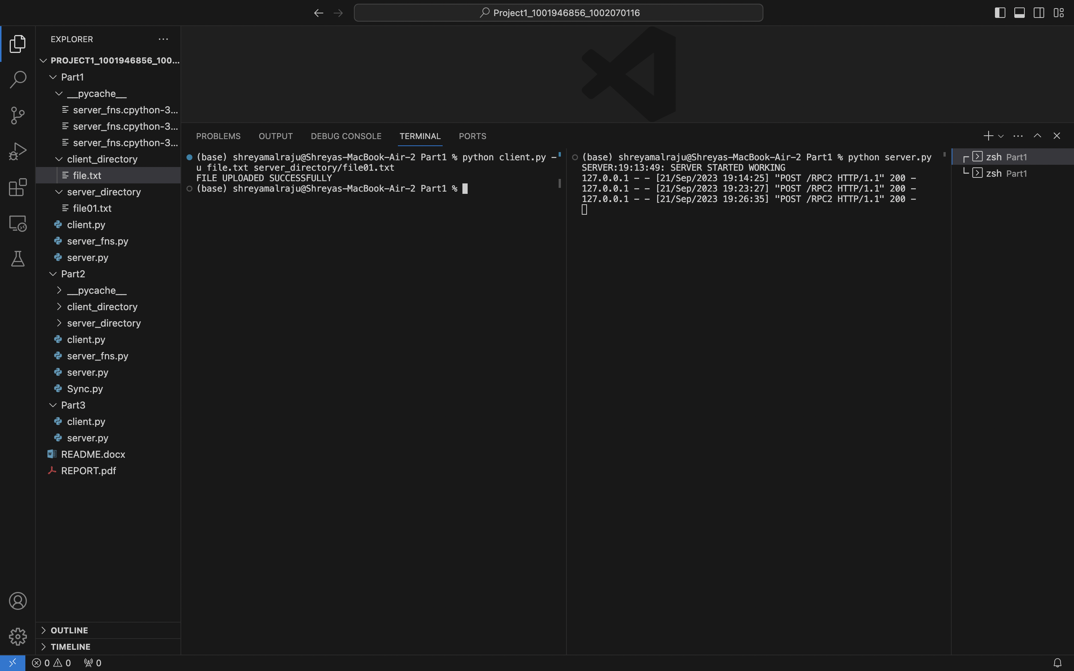

By listing the files on the server, we can verify that a file has been uploaded to the server by using following command: python client.py -l server

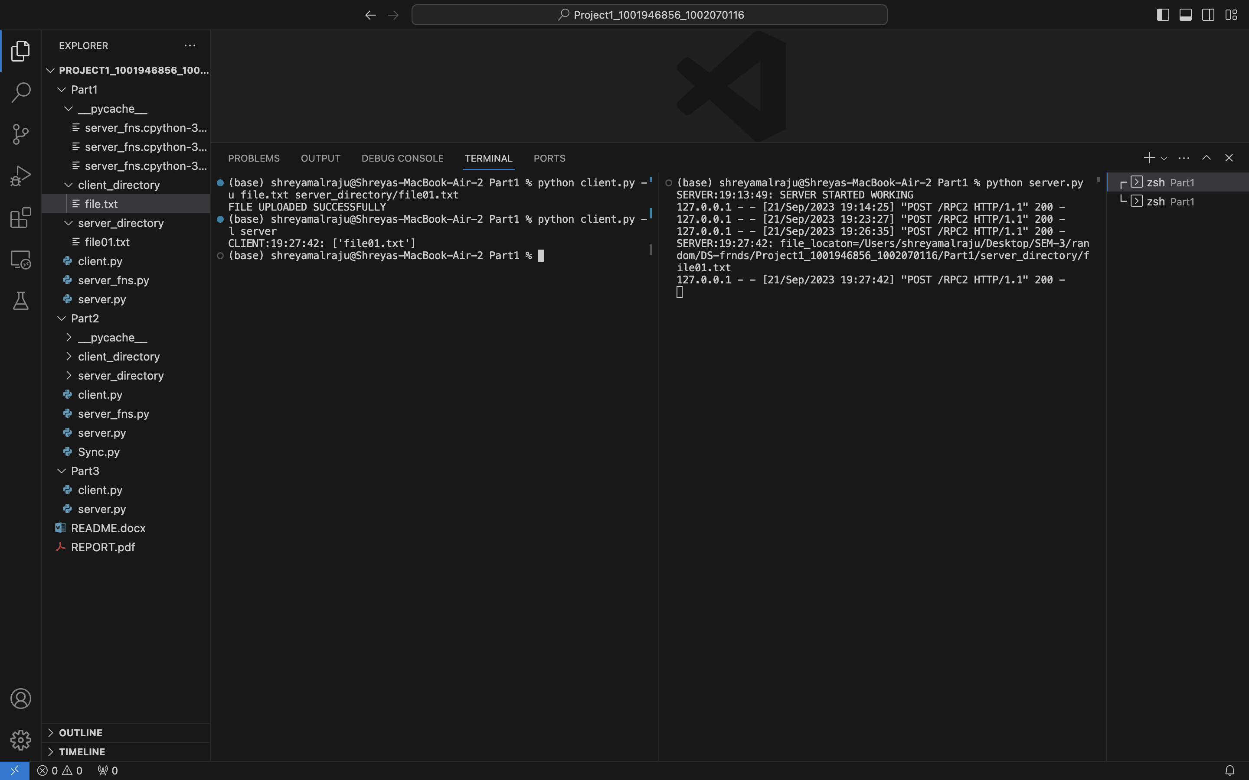

**Performing Download Operation:**

Download the file from server by running the following command: python client.py -d server_directory/filename client_filename

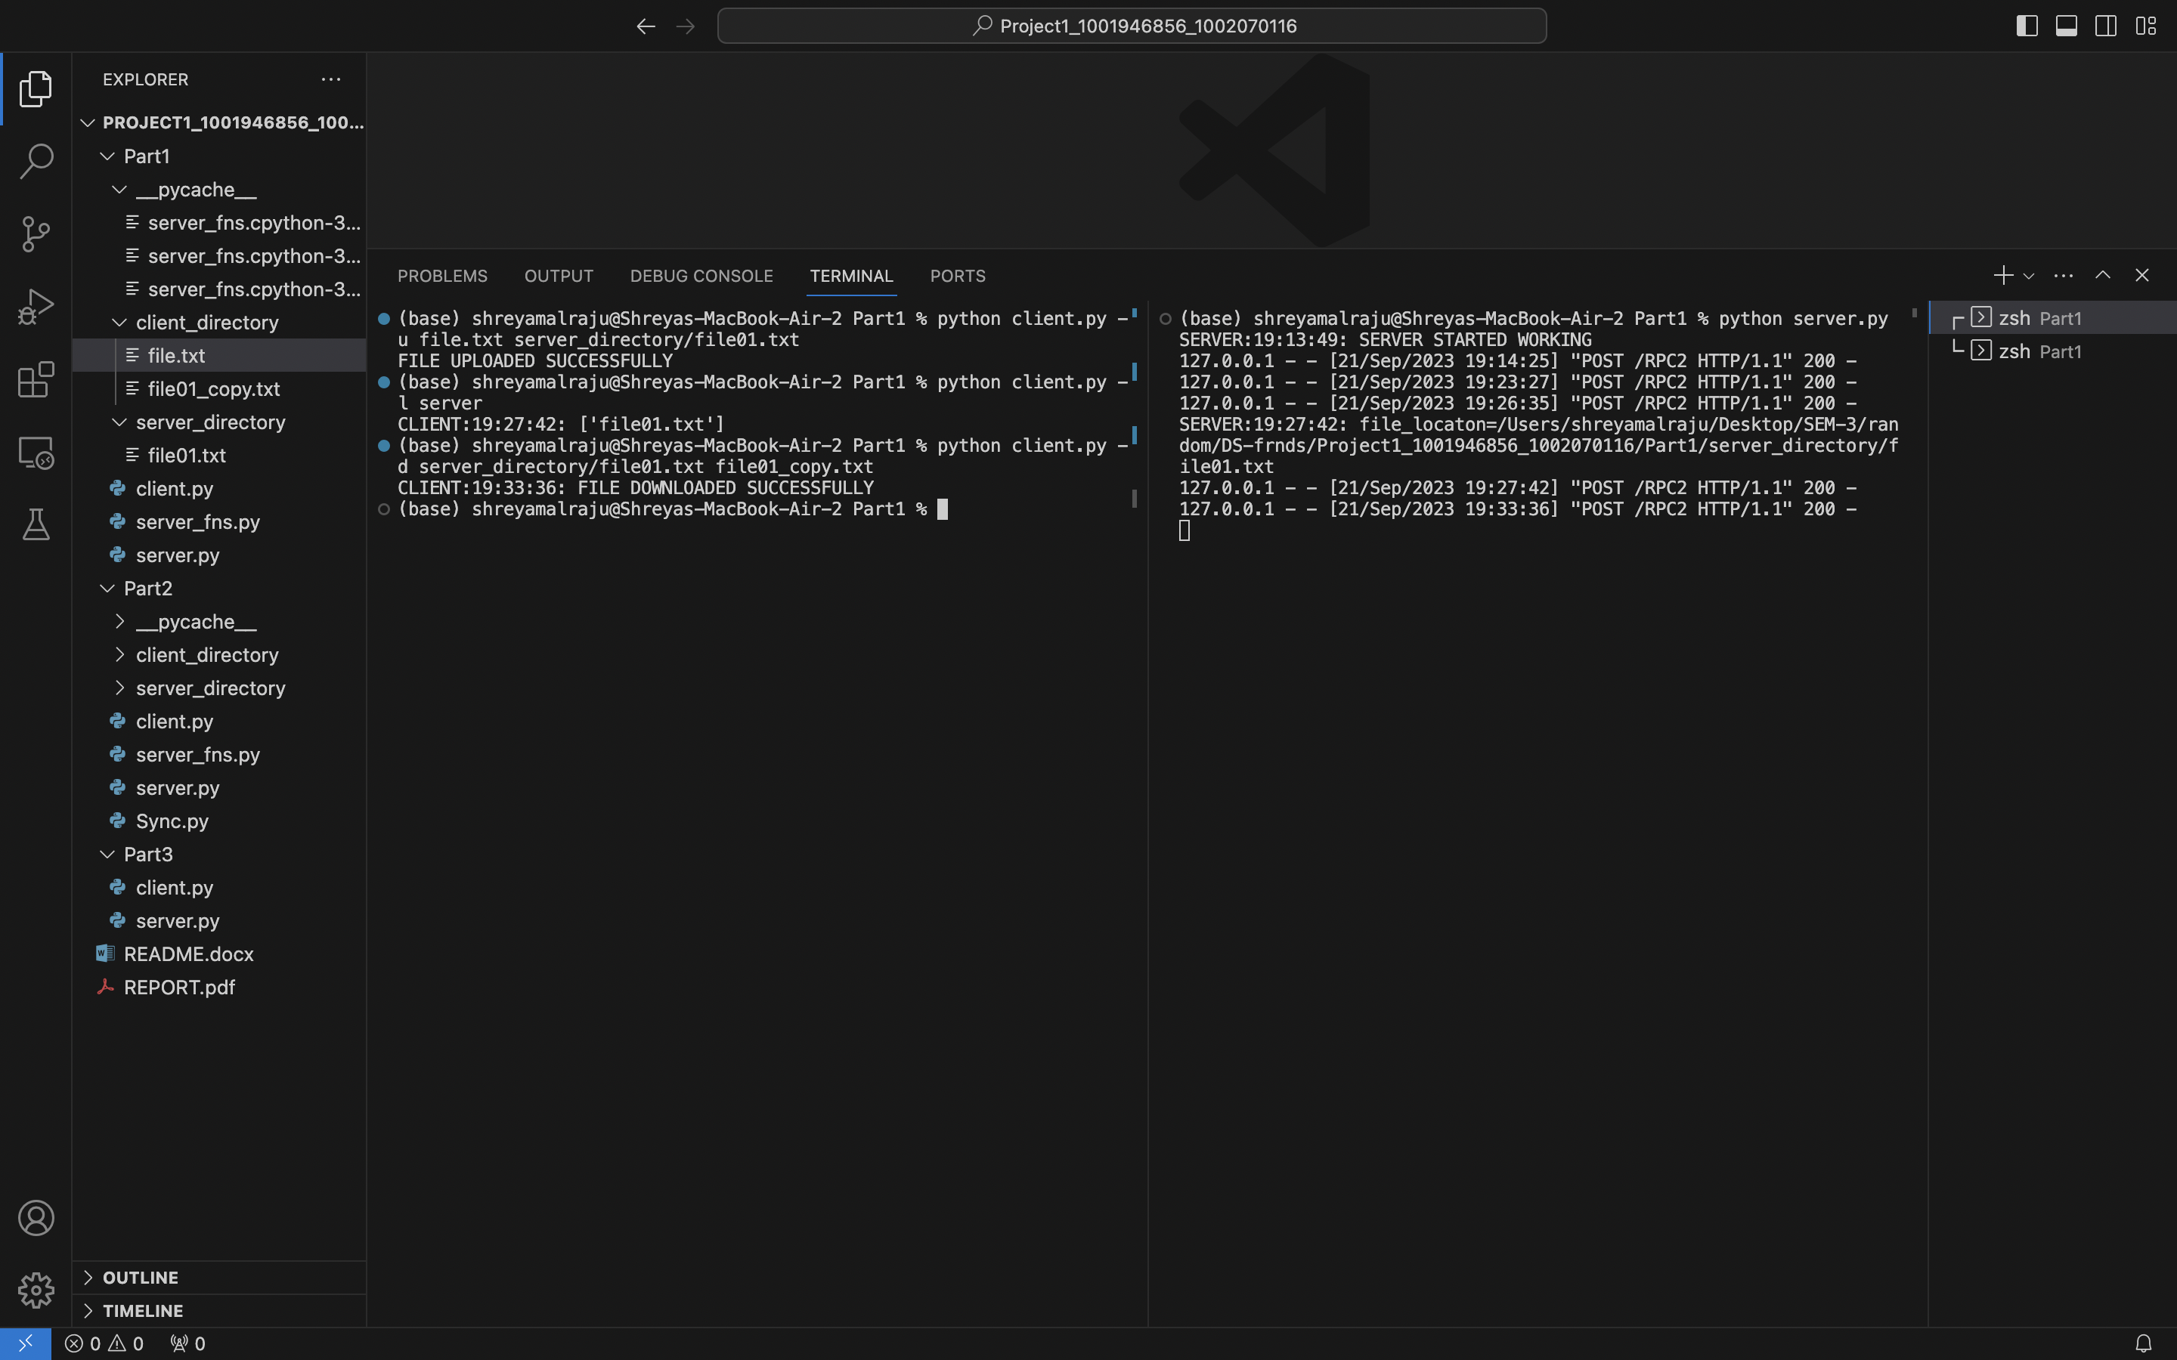

By Listing the files on the client allows us to verify that a file was downloaded from the server:

client.py in Python, -l client

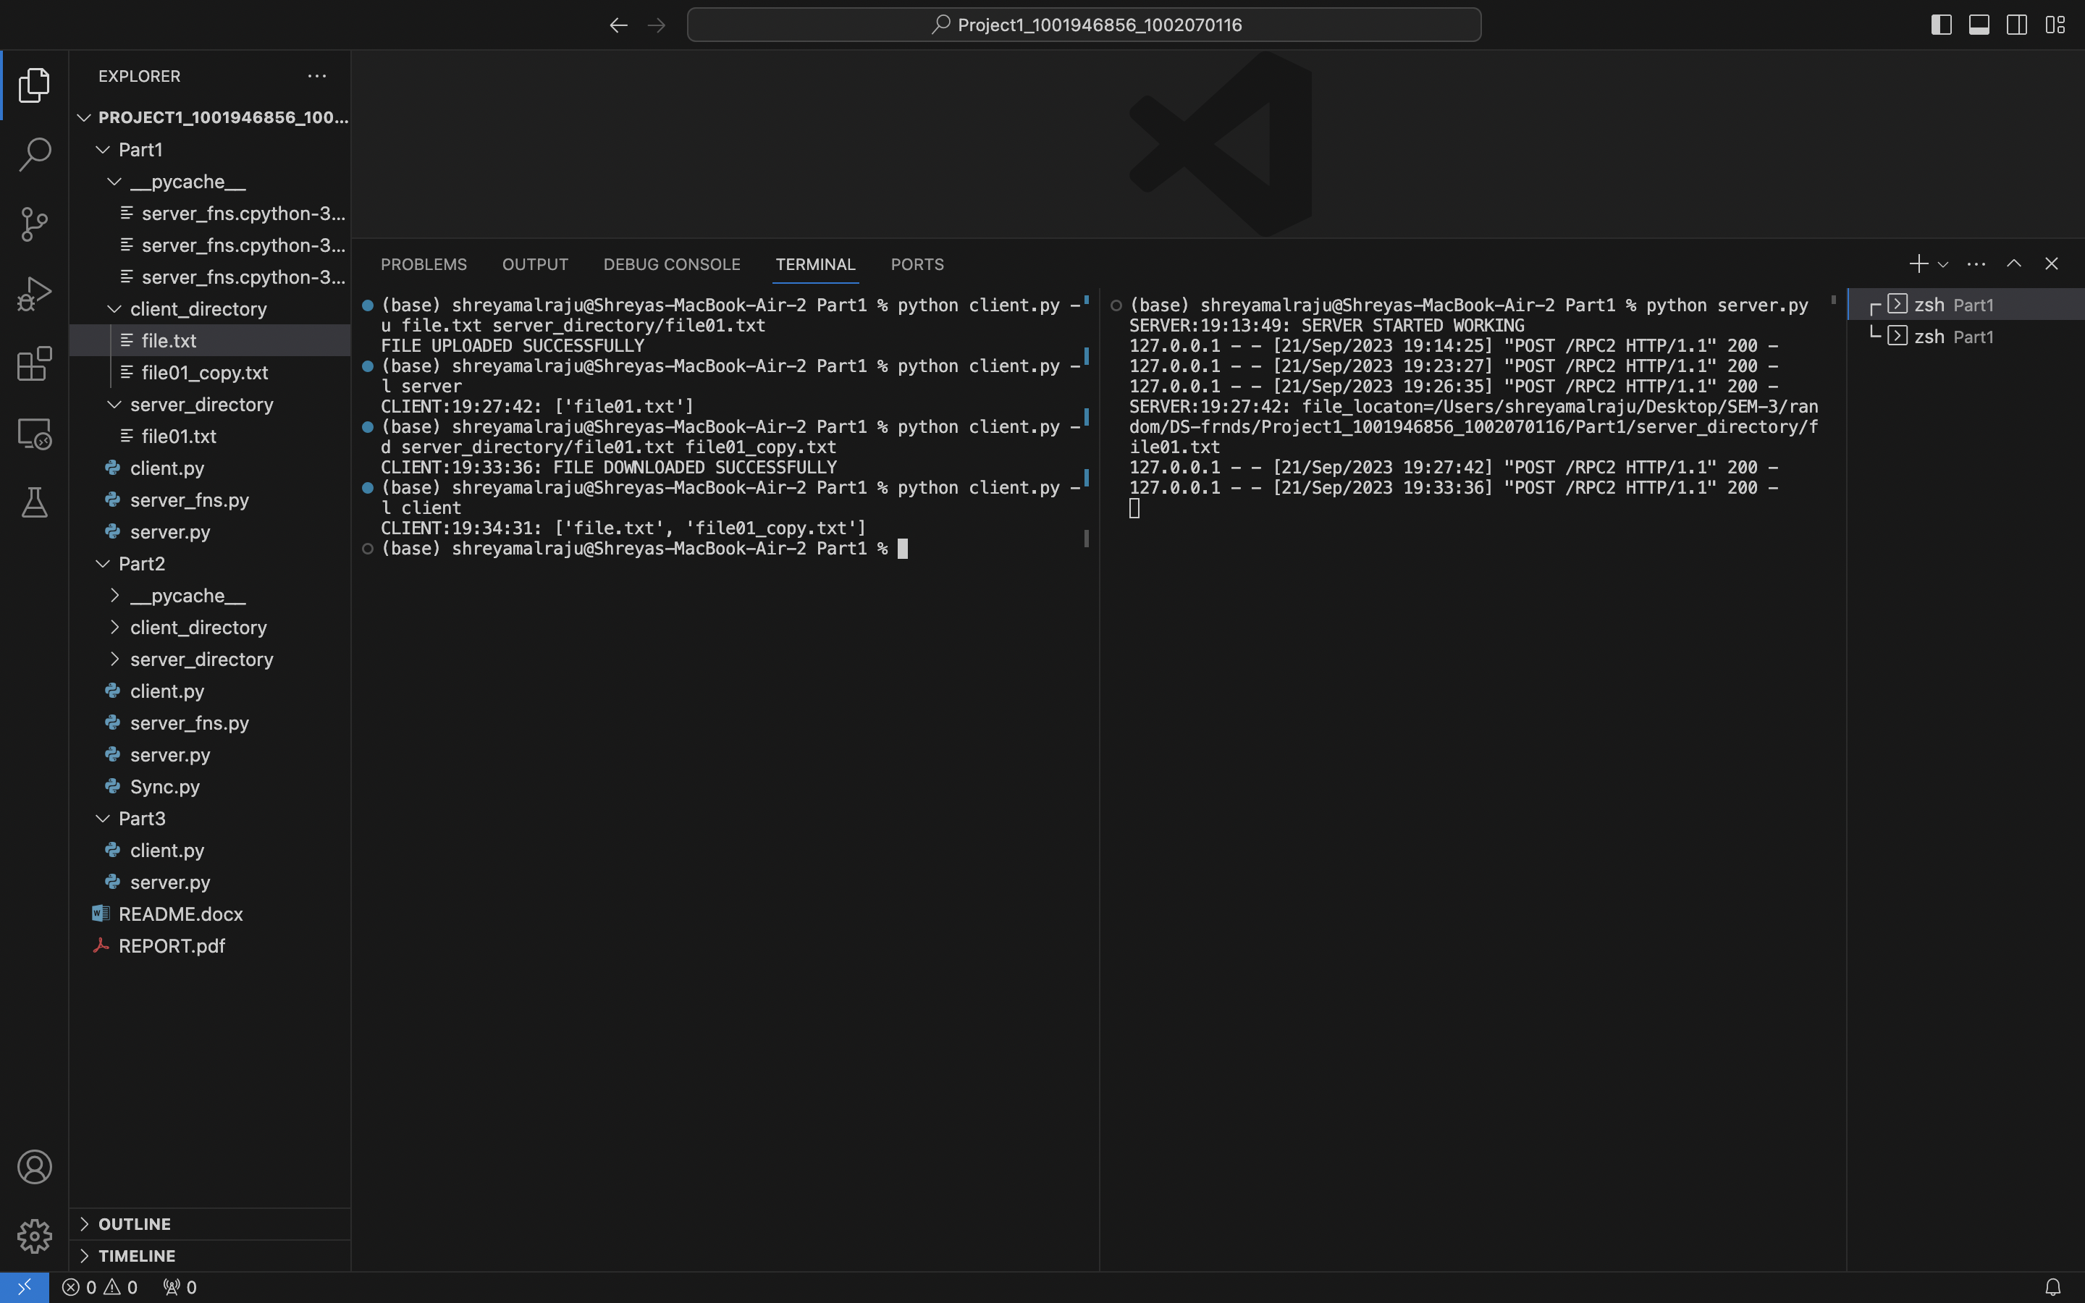

**Performing the Delete Operation:**

Executing the following command will delete the specified file from the file server:

python client.py -del server_directory/filename

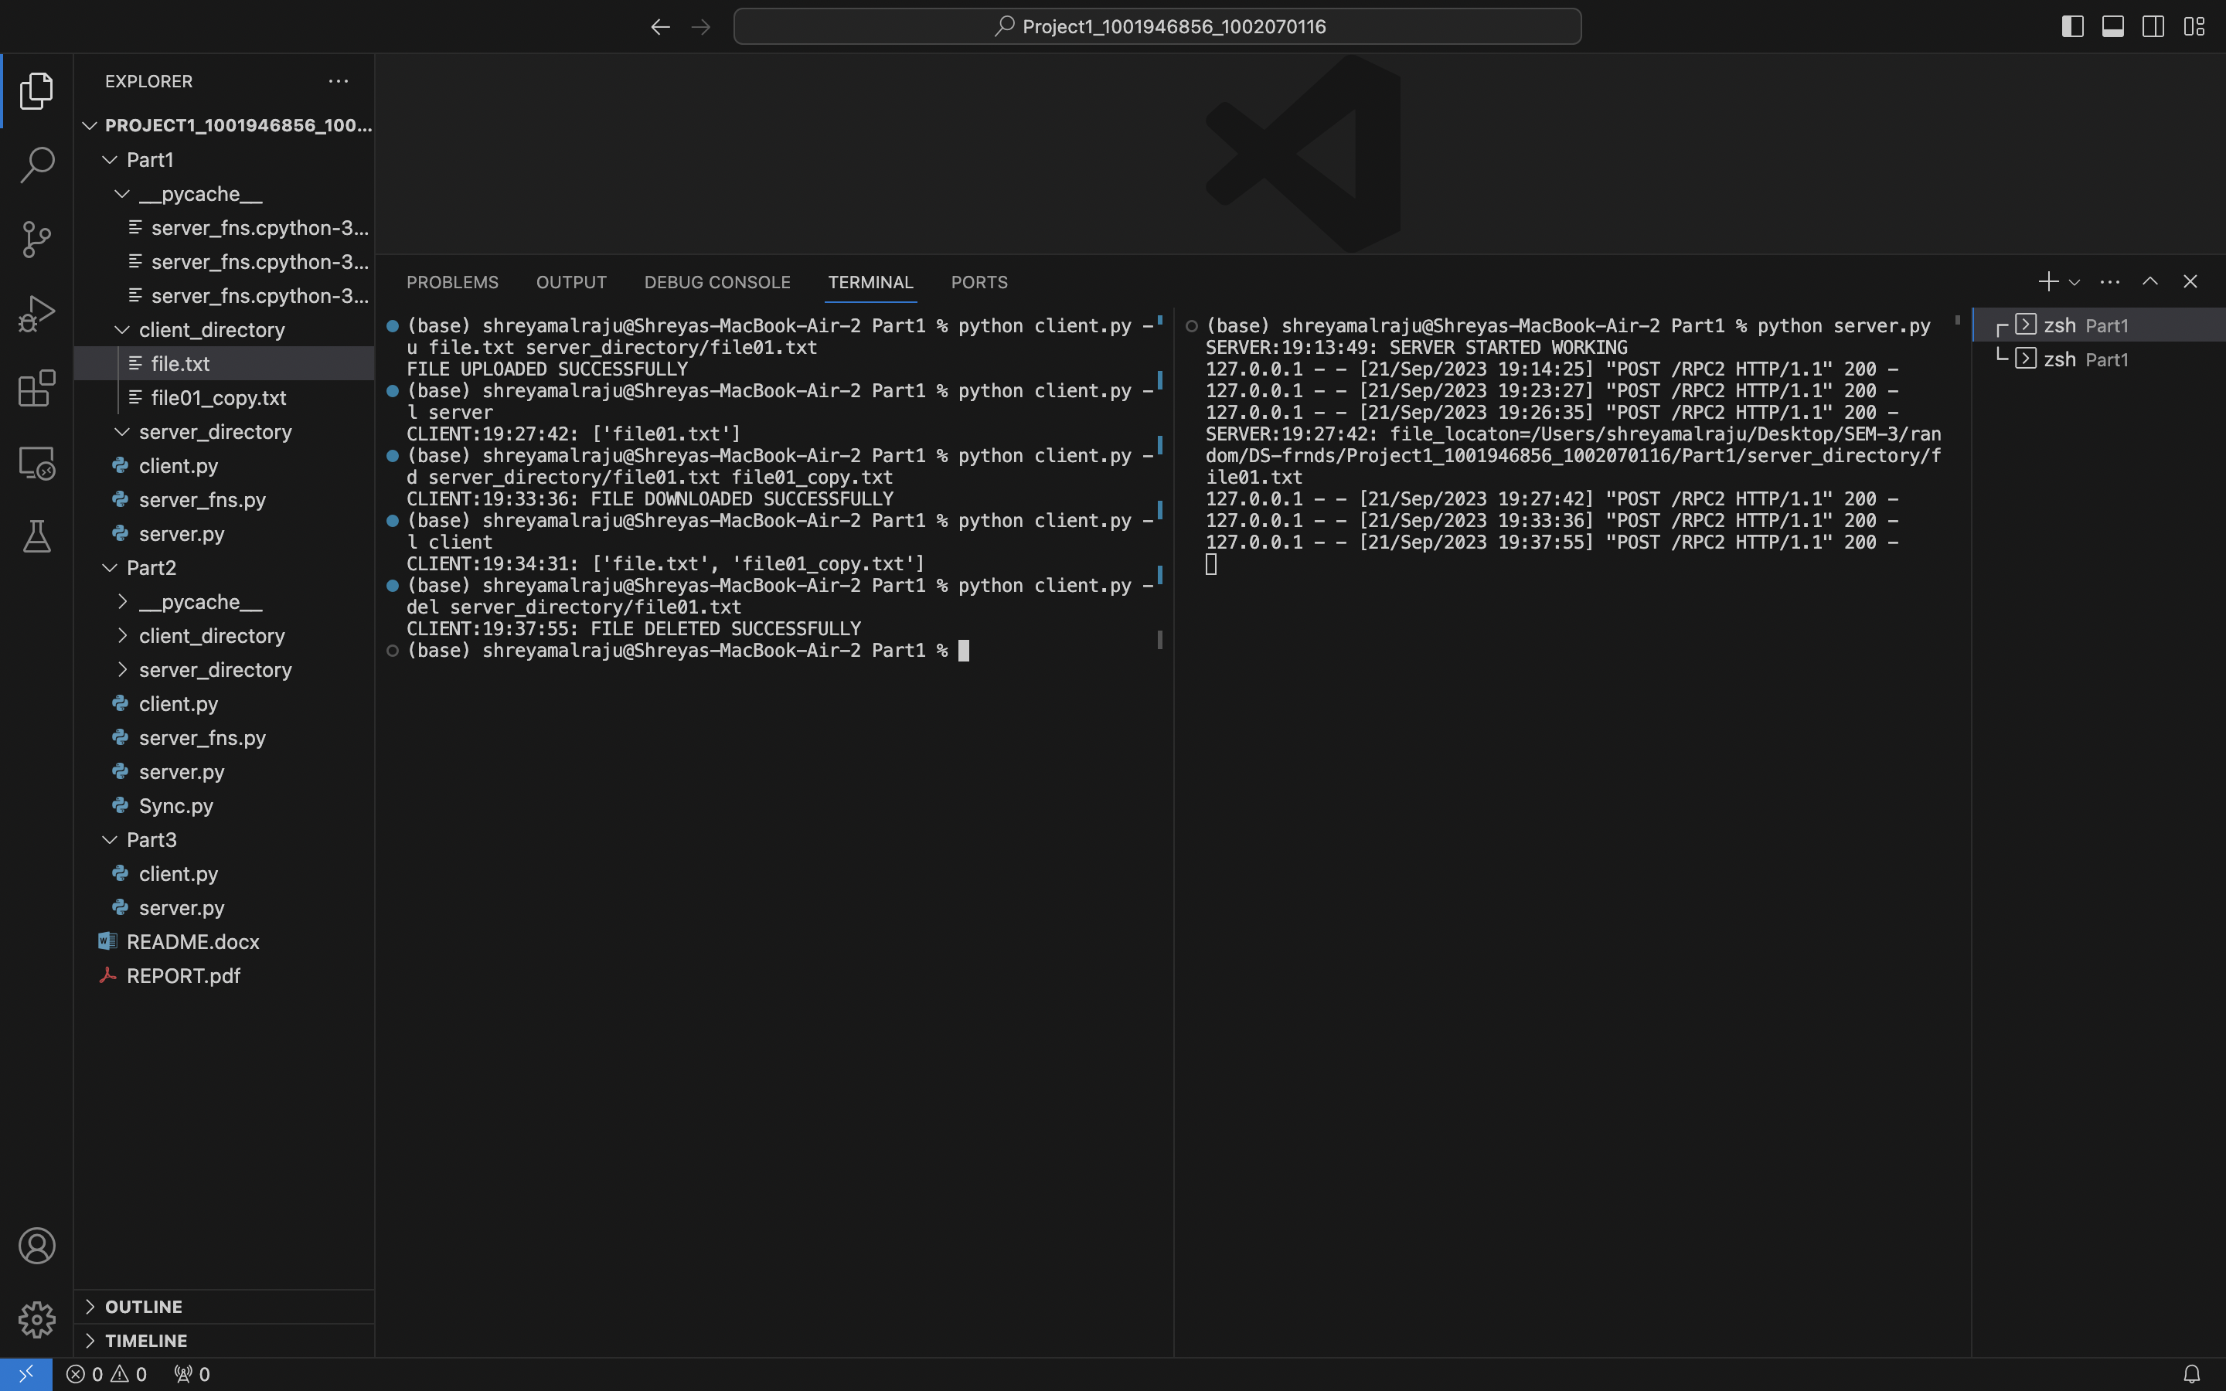

After deleting a file from the server, we can see the file was deleted on server by using the below command: python client.py -l server

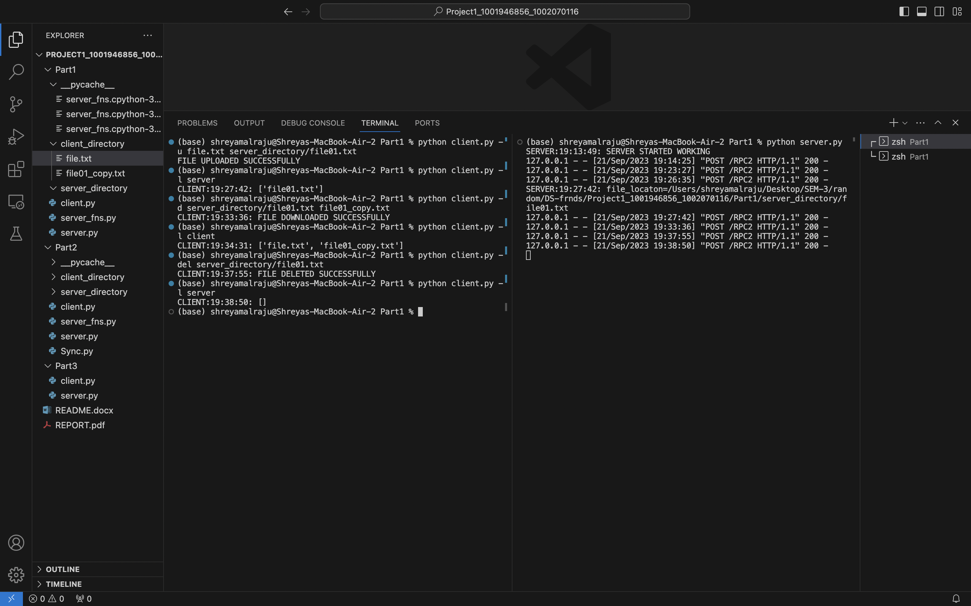

**Renaming the File:**

Verifying whether the file has the same name on the client and server directories.

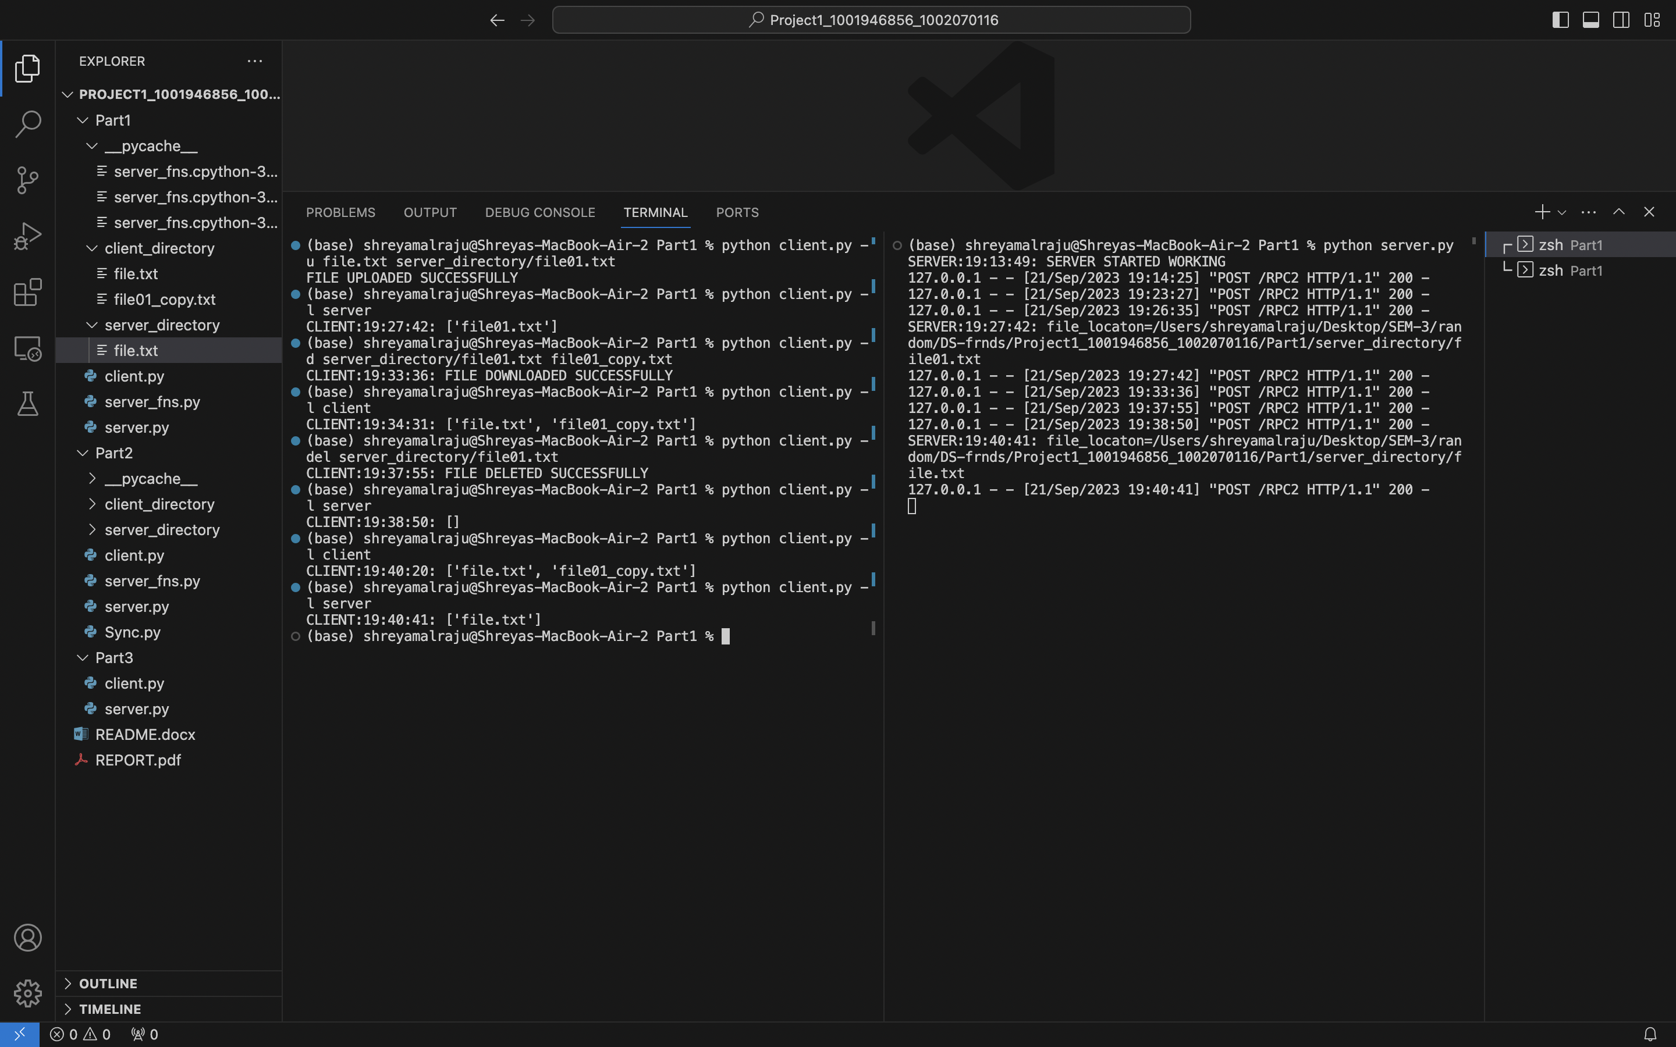

We can rename the file on the server by running the following command: python client.py -r filename new_filename

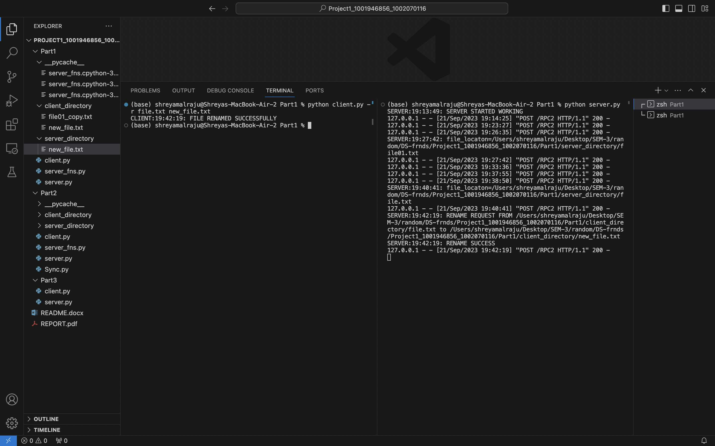

After renaming the file on the server, we can verify the files are renamed on the server and client by the following commands: python client.py -l client

python client.py -l server

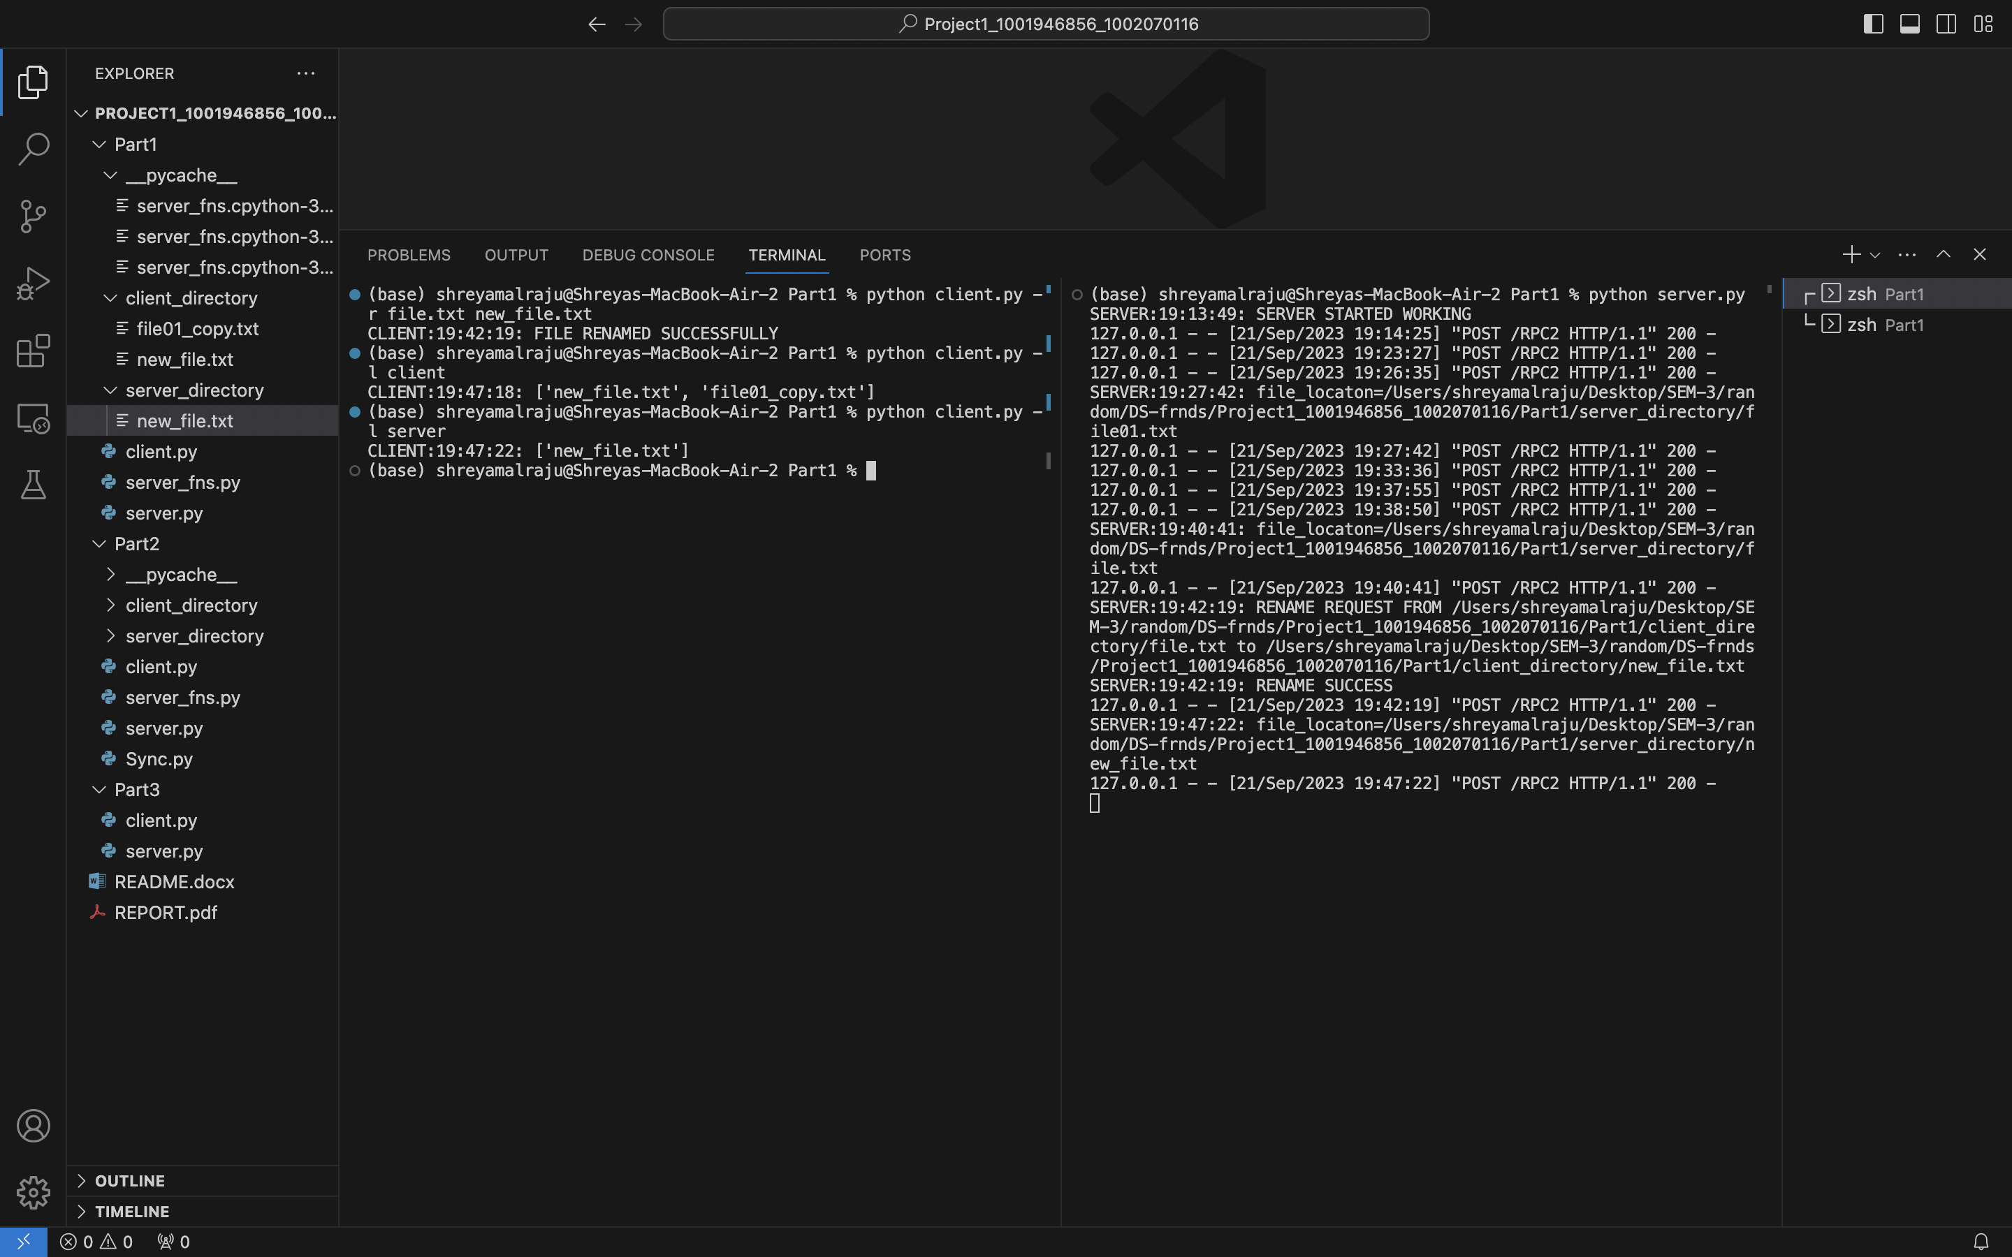

**Part 2 : Synchronized Storage Service**

Contribution – By Shreya and Jyothi

Start to run the server

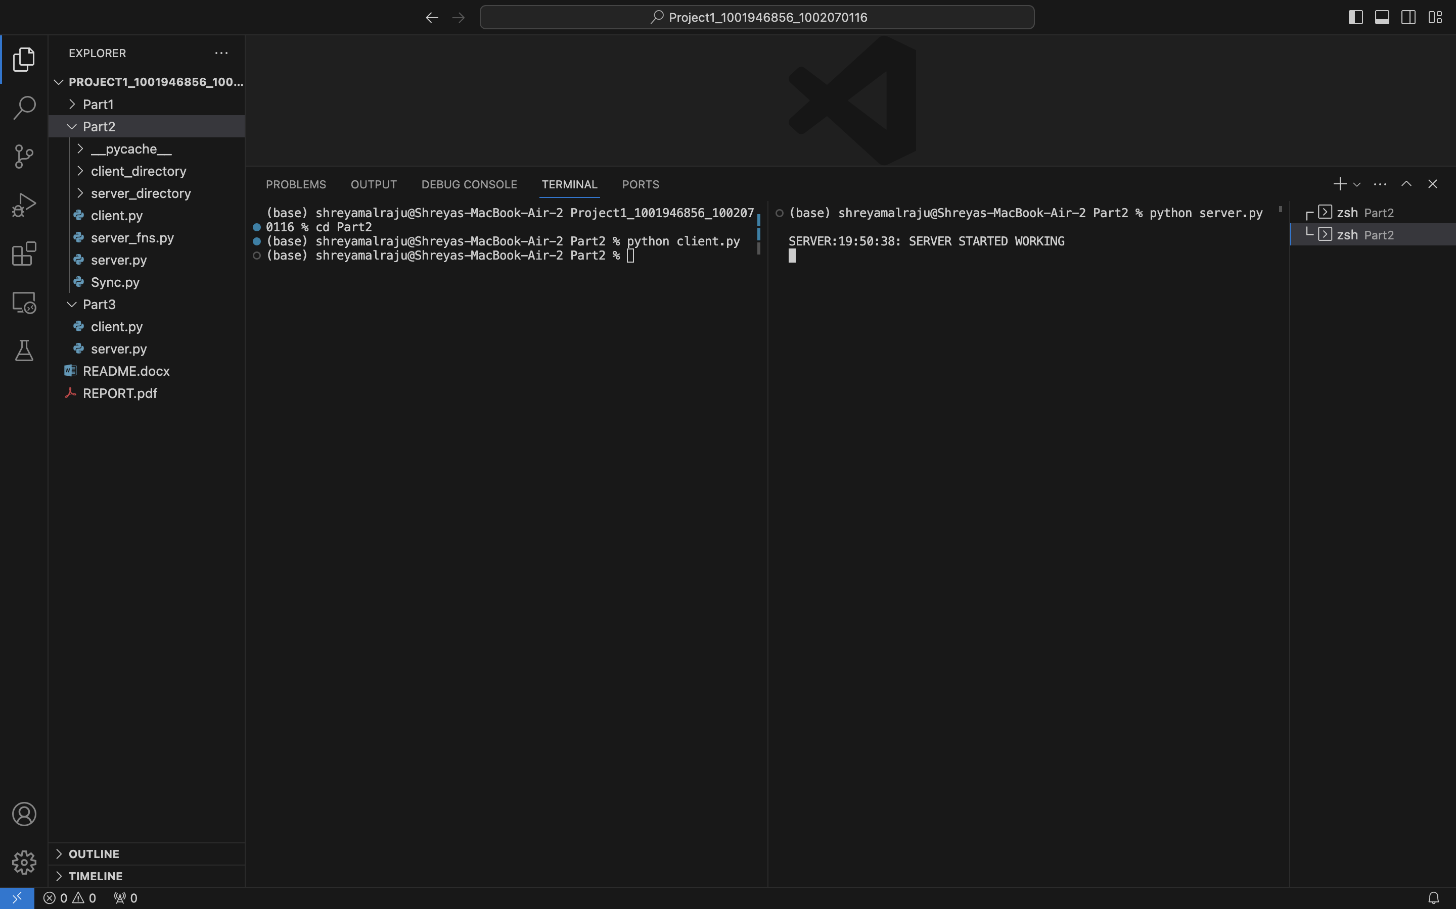

Firstly, let's check whether the files are available in both the client and server

python client.py -l client

python client.py -l server

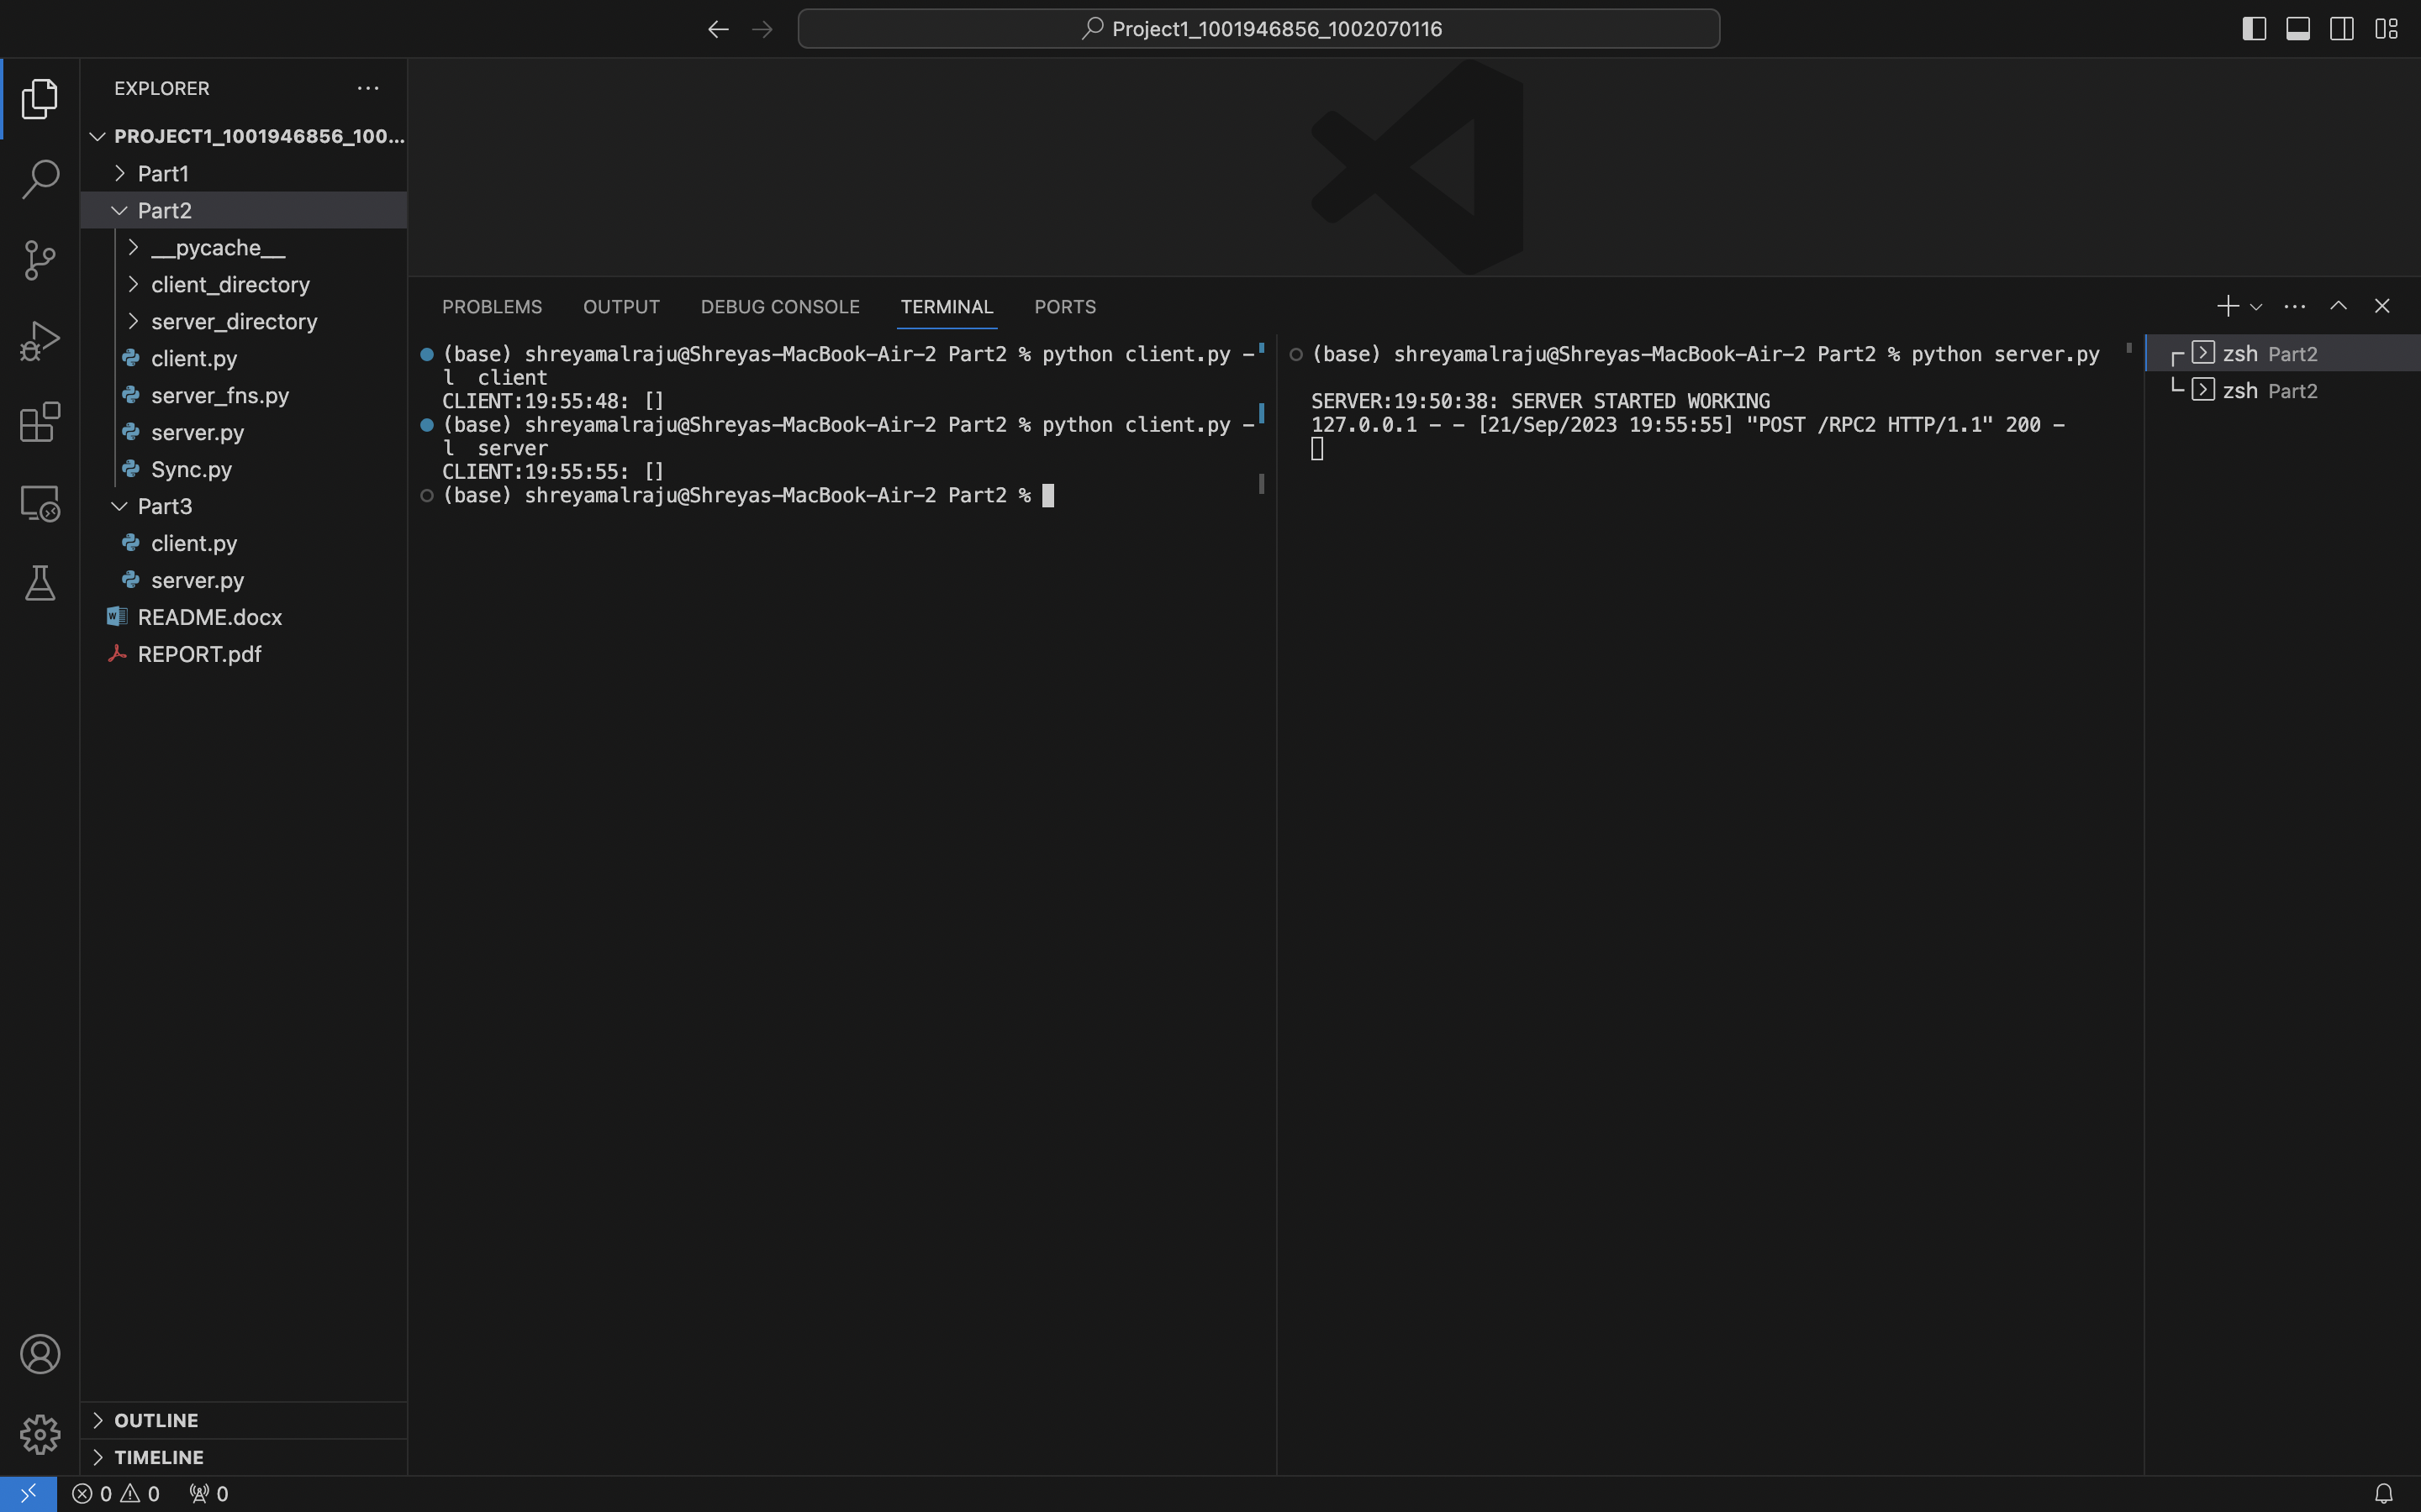

Once the server is started, start to run the Sync.py by using the following command:

Python Sync.py

Perform Upload, modification and deletion of files, we can see changes after 10 seconds on the terminal.

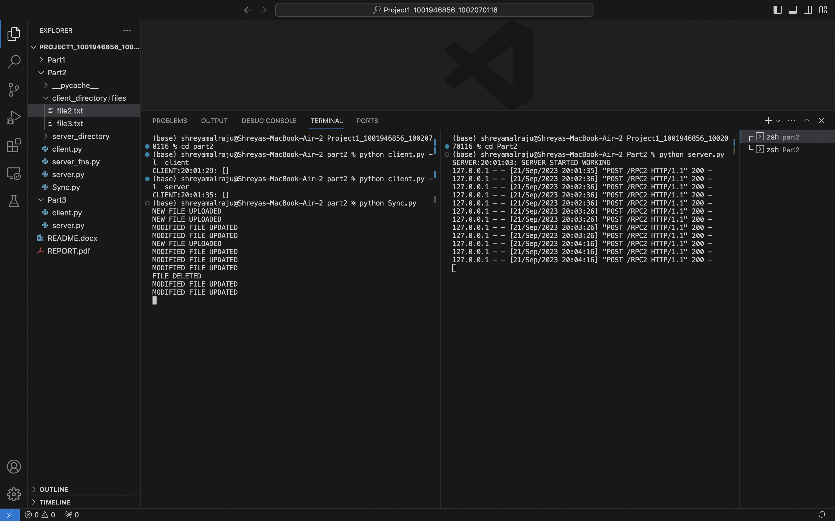

**Part 3 : Synchronous and Asynchronous add() and sort()**

Contribution – Synchronous Operations – Shreya

Asynchronous Operations – Jyothi

Open 2 terminals and start the server on one terminal using the command python server.py and start the client module on the other terminal using the command python client.py

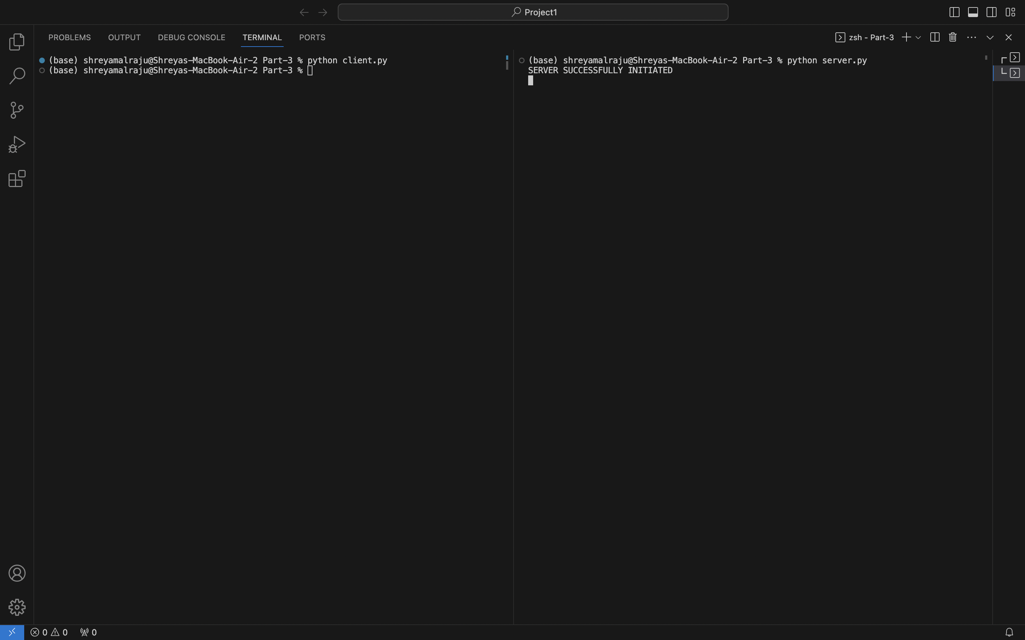

the computation So what supports 2 functions addition and sorting in both synchronous and asynchronous manner.

When we perform synchronous addition or sorting we make a request directly to the server and server directly sends the result to the client there is no delay in the response.

If we perform addition and sorting in asynchronous manner, the client requests the server for the response and first server sends an acknowledgement to the client and then the client uses this acknowledgement number to access the result when the computation is ready.

**Synchronous Addition**

To perform Synchronous addition, use the command python client.py -ads 10 10. We can observe that the response is obtained instantly.

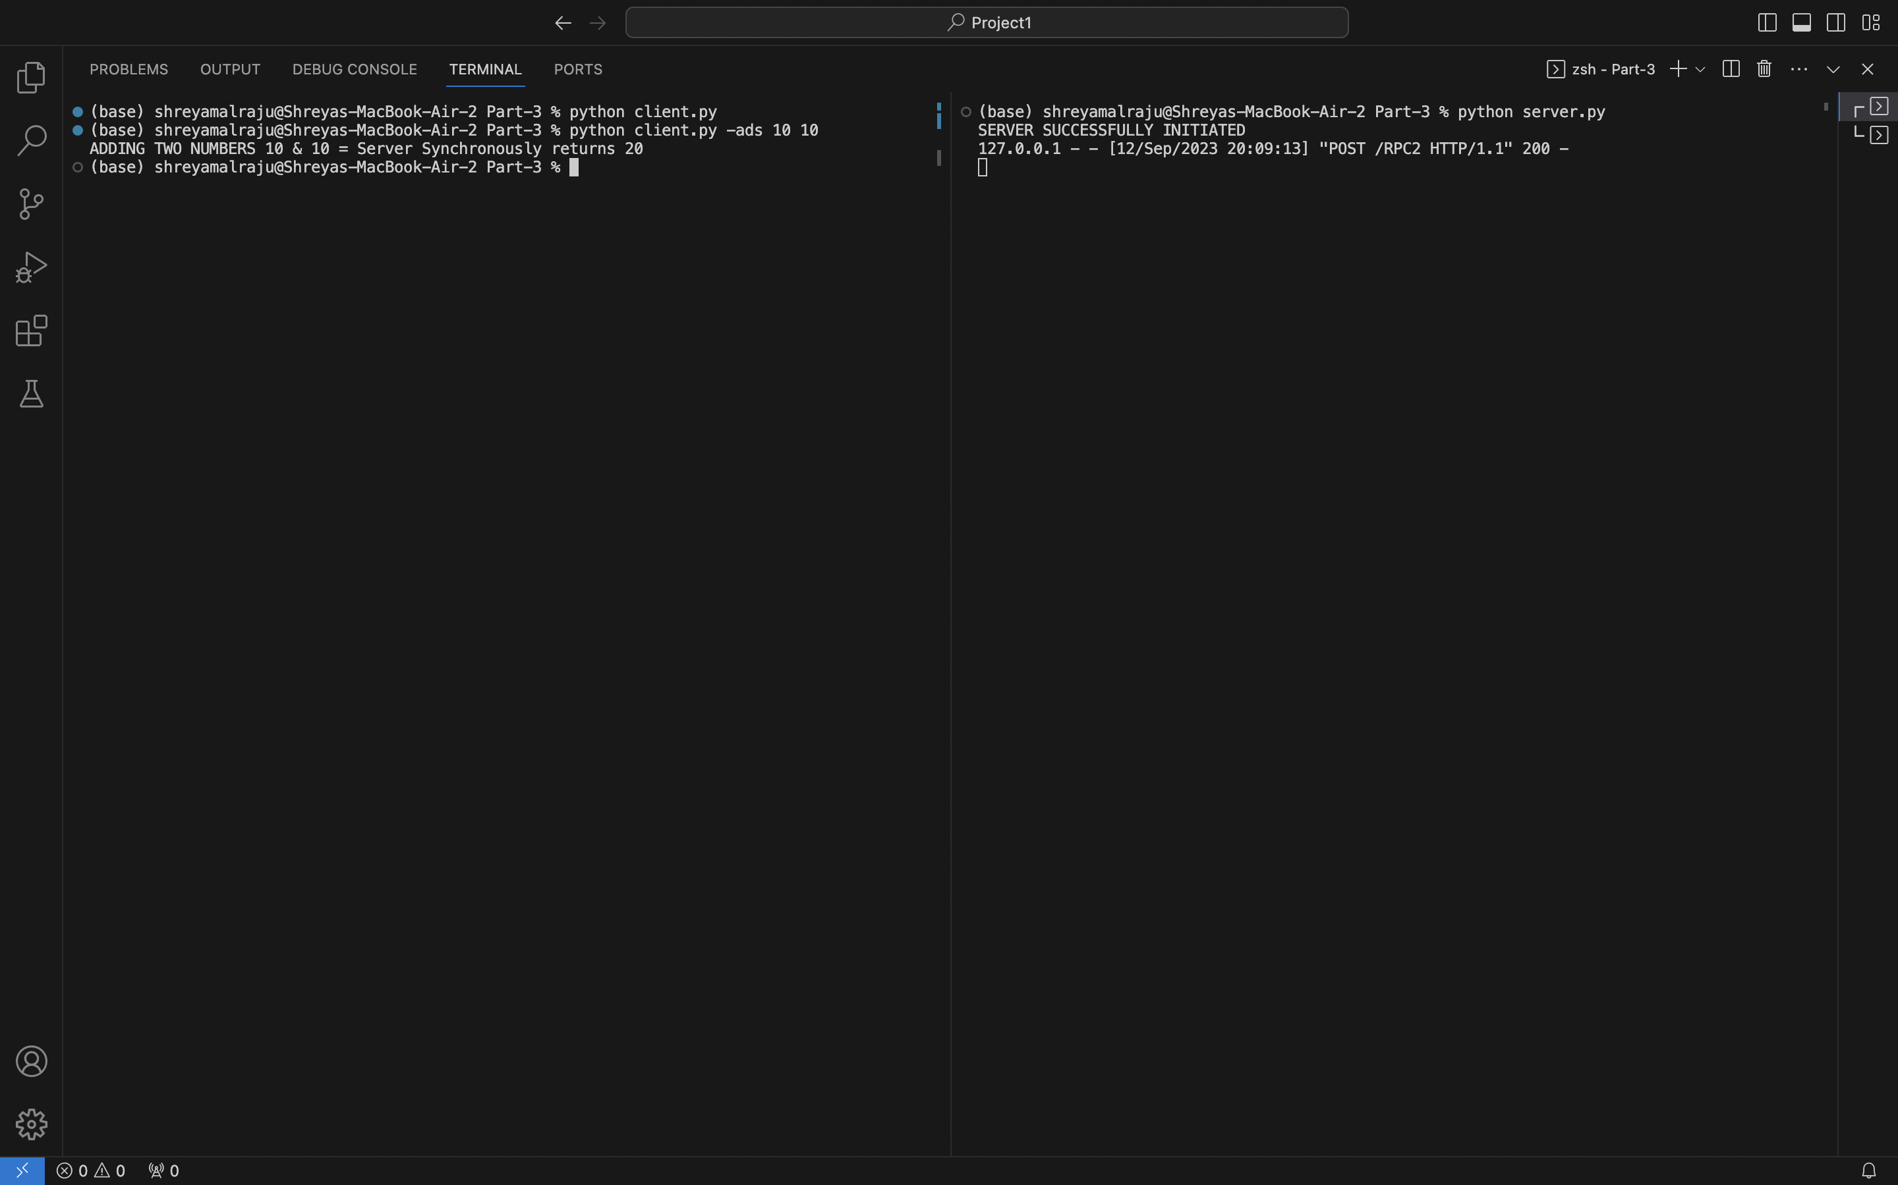

**Asynchronous Addition**

Addition is performed by using the command shown below Python client -asad 10 10. After executing this command we get an output from the server which is the acknowledgement number . We use this acknowledgement number in the below command to get the output of the original command. Python client.py -ack num.

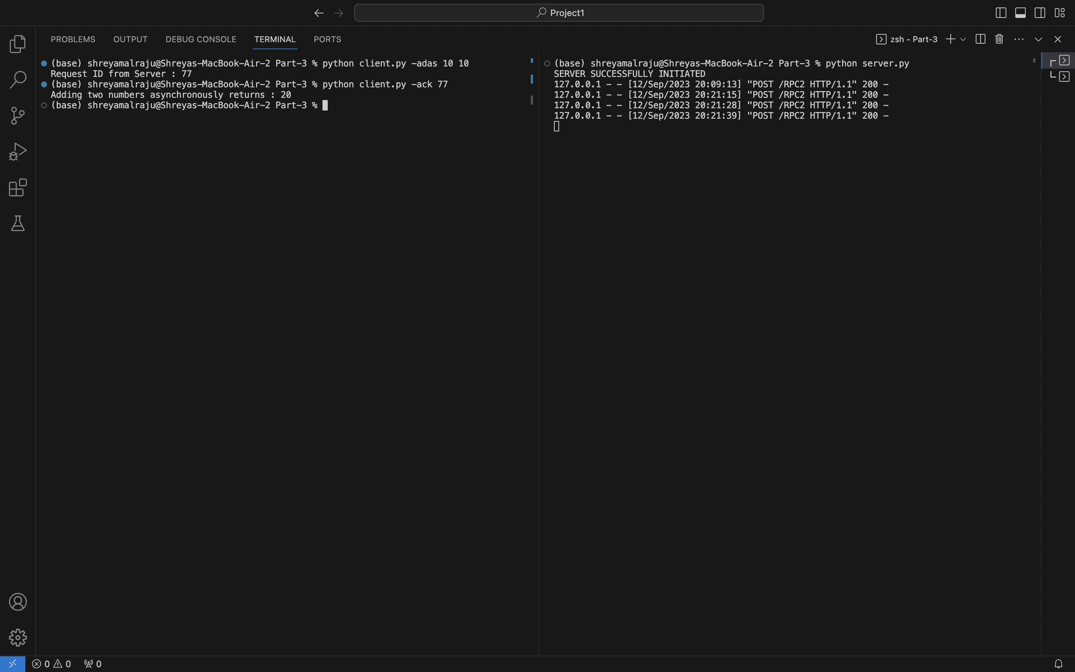

**Synchronous Sorting**:

Synchronous sorting of 5 different numbers is performed using the below command.

Python client.py -ss n1 n2 n3 n4 n5

We see that the result is a sorted array in the increasing order which is obtained directly from the server as soon as the request is received.

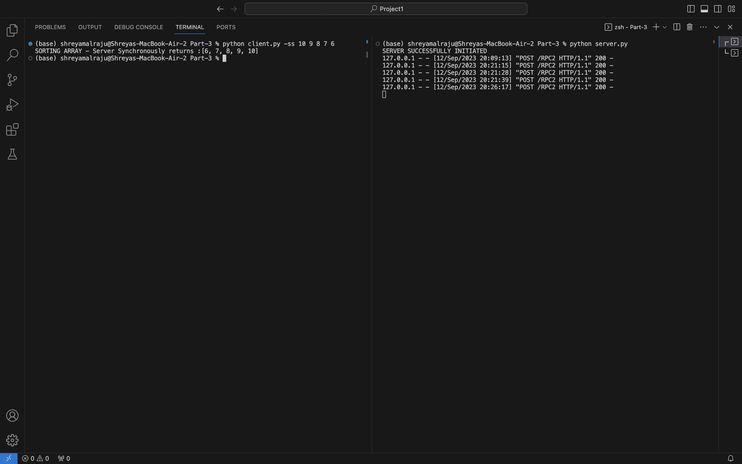

**Asynchronous Sorting**

The same sorting can be performed using asynchronous method using the below command Python client.py -sas n1 n2 n3 n4 n5

As soon as this command is executed we receive an acknowledgement number from the server end whether result array is stored we use the below command to access the result at that particular location. Python client.py -ack1 1

